**Case Study**

* Ashwin Harish P

1. **Uploading CSV to Azure**

Creating a new container “Retail Sales” in Azure

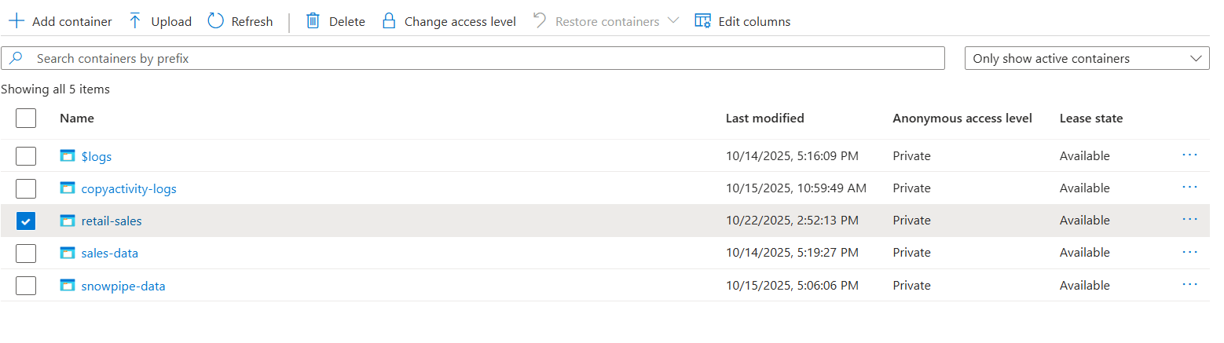

Uploading csv file in the container

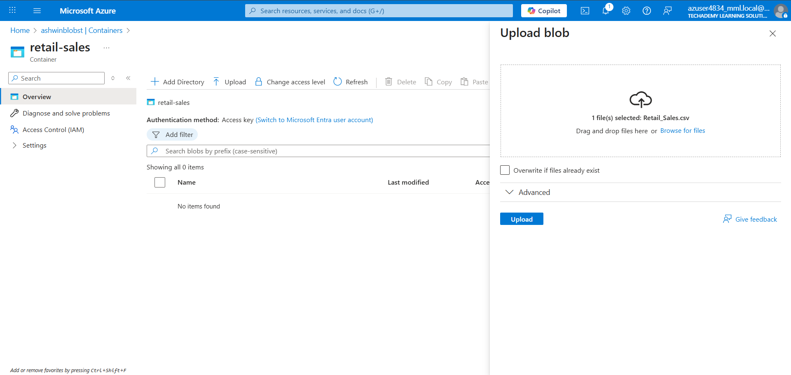

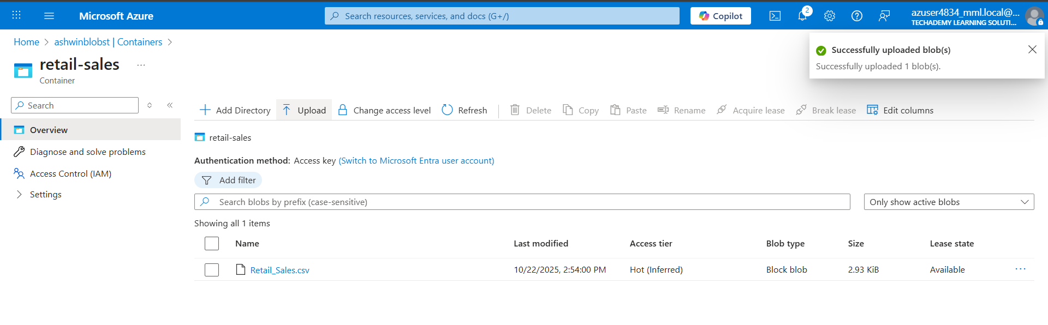

1. **Ingest it into Snowflake using Snowpark,**

**Creating a new database and schema**

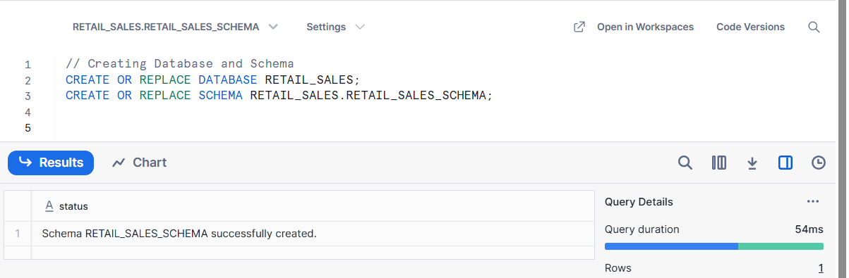

**Creating a new integration which points to azure**

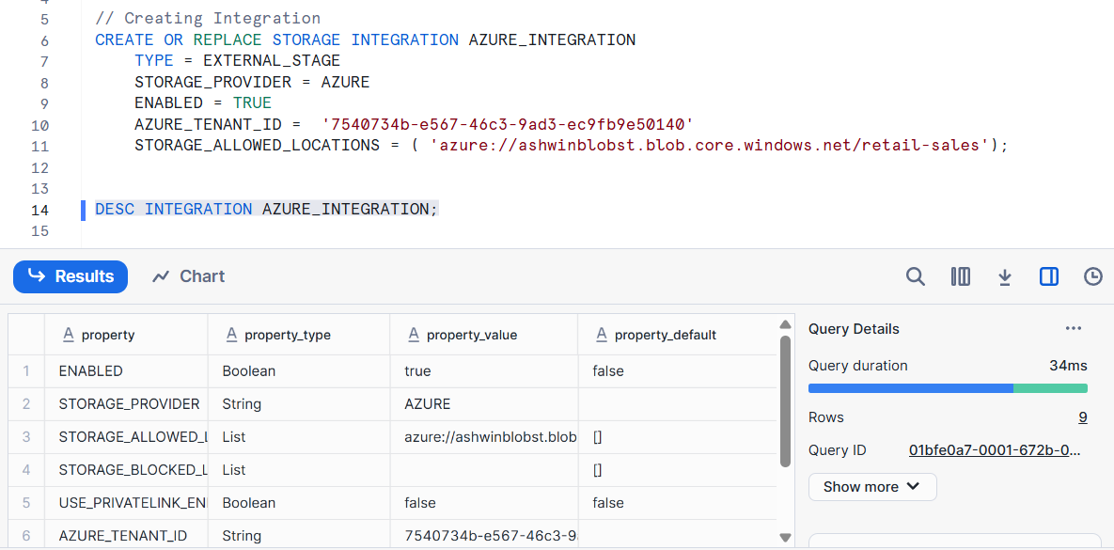

**Creating a file format**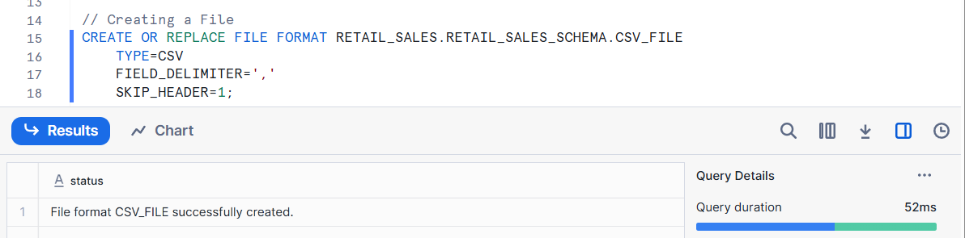

**Creating a Stage**

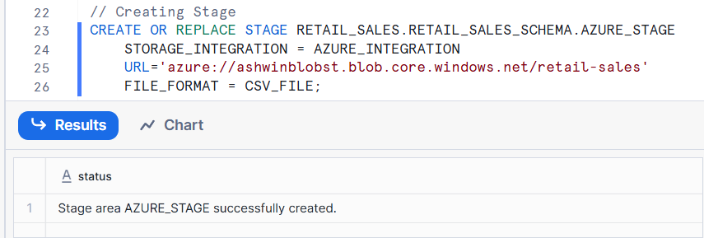

**Listing files in Stage**

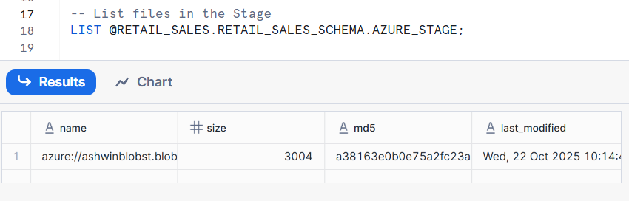

**Creating Table**

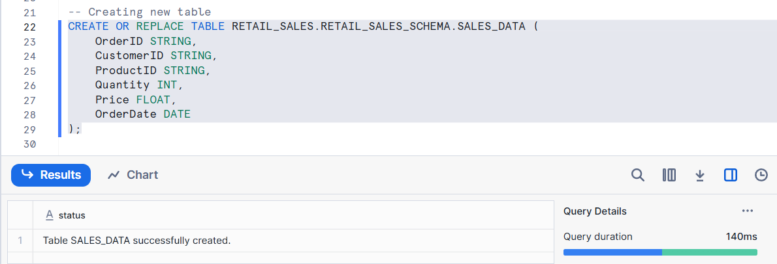

**Doing Transformations in Snowpark**

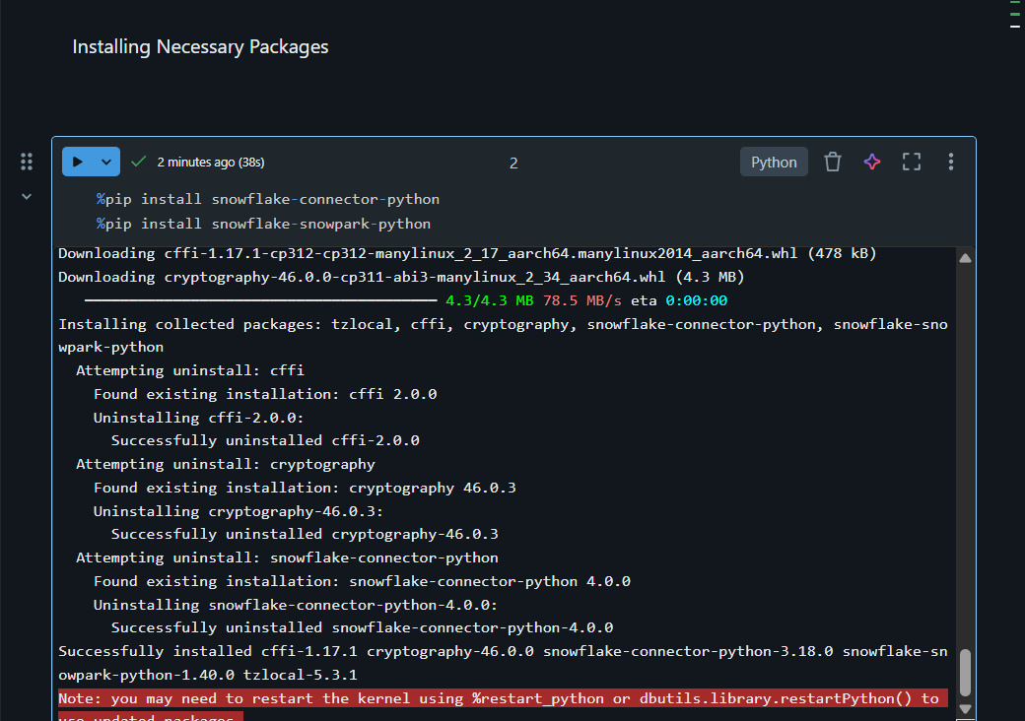



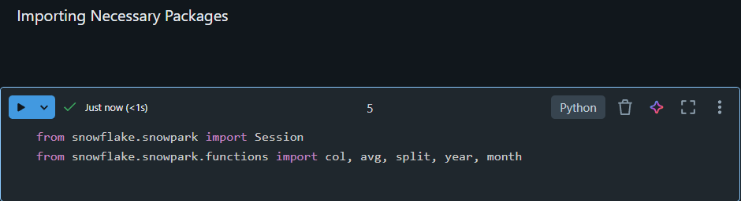

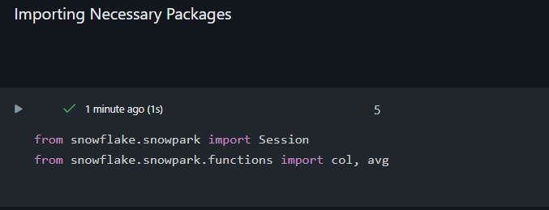

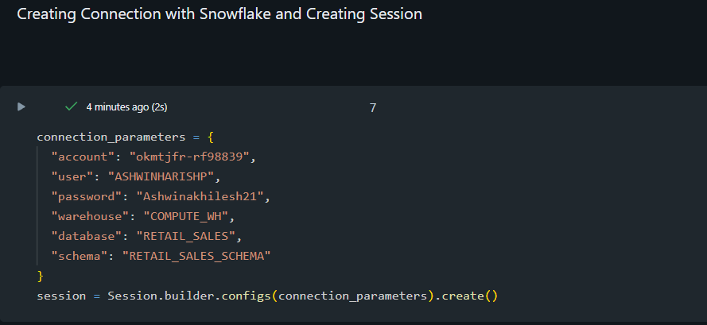



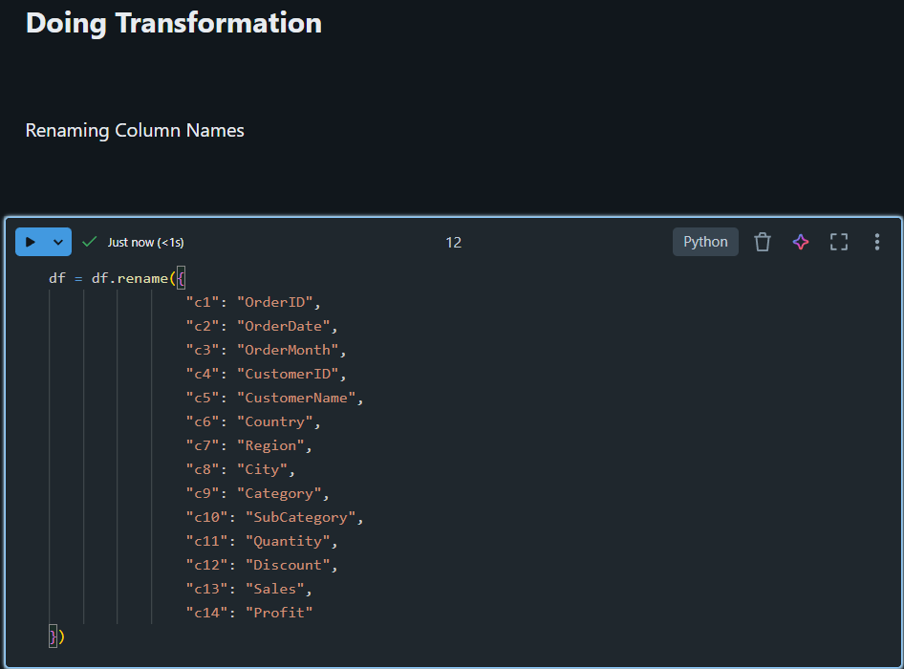

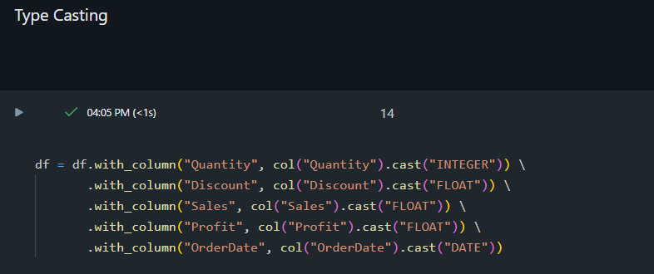

**Injecting to a Snowflake Table**



**Verifying Data in Snowflake**

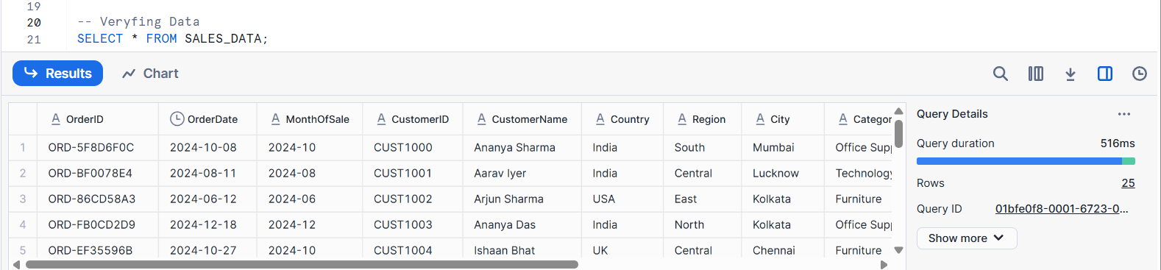

**Generating Power BI Report**

**Loading Data from External Source-Snowflake**

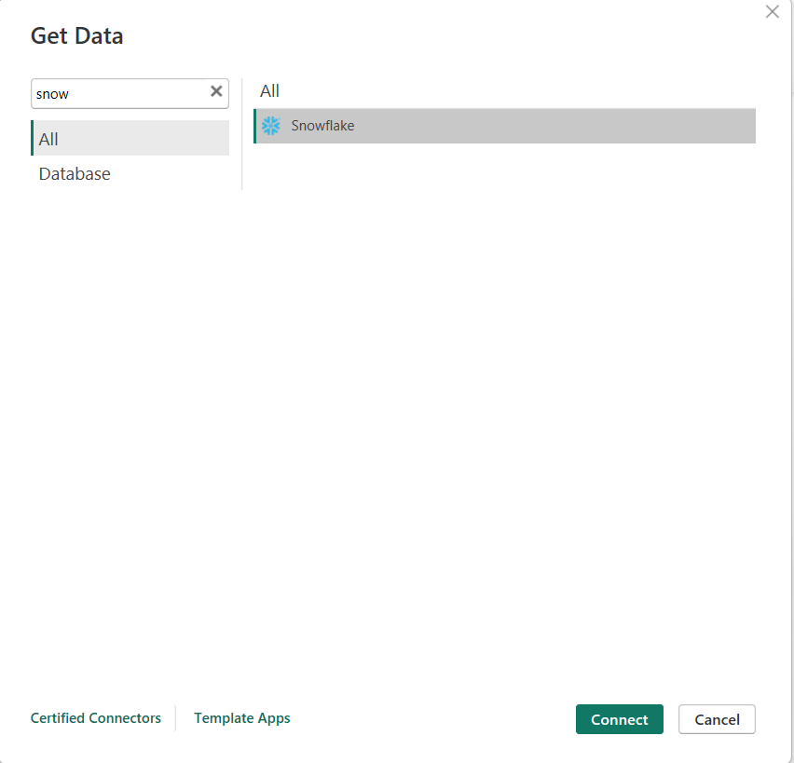

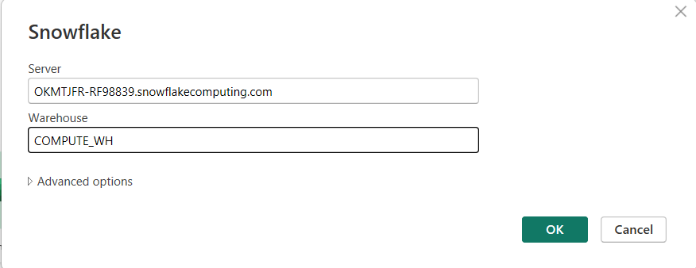

**Transforming Data**

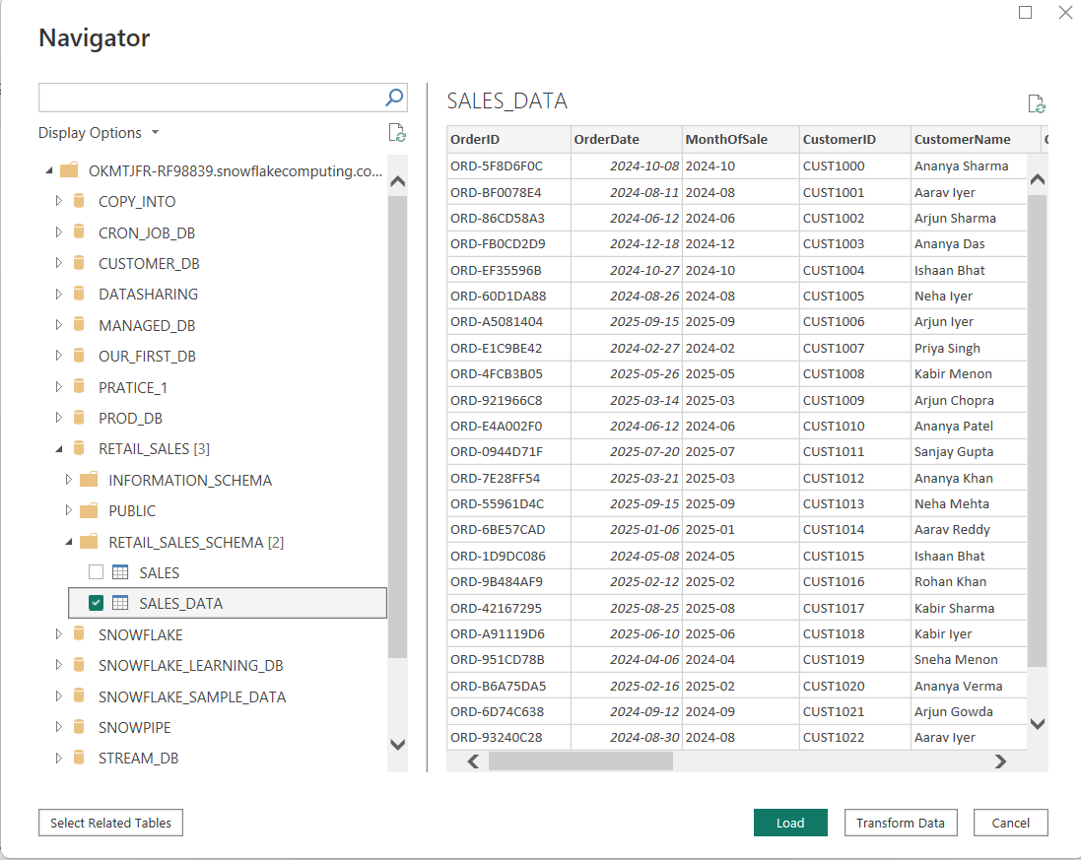

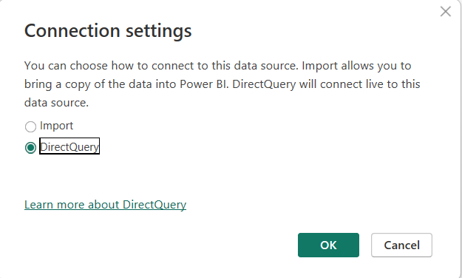

After making some transformation, I loaded the data

**Visualizations**

1. **Sales of Each City and Country using Drill Through**

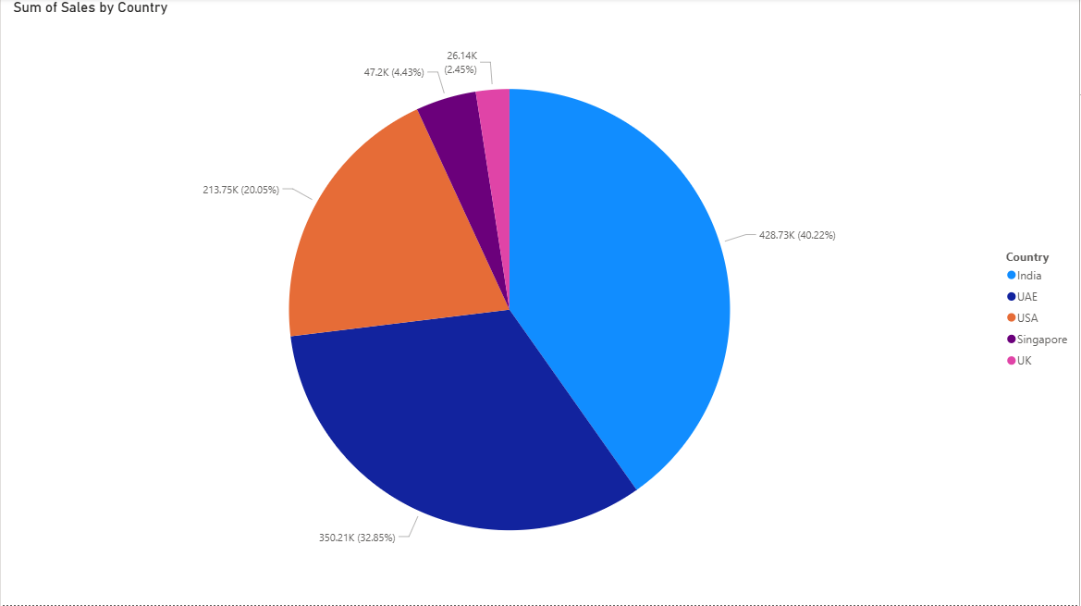

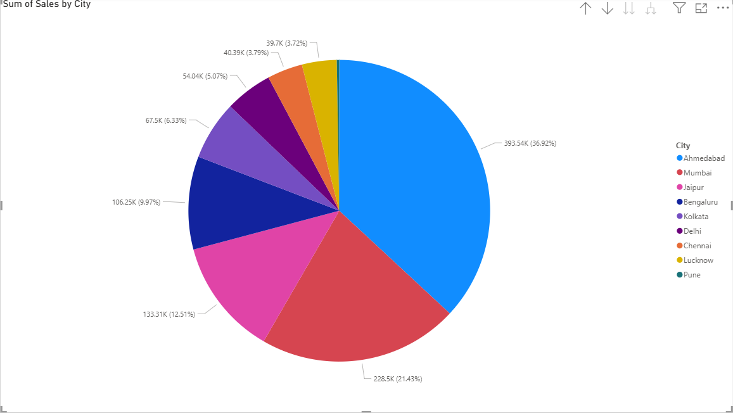

1. **Profit of Each City**

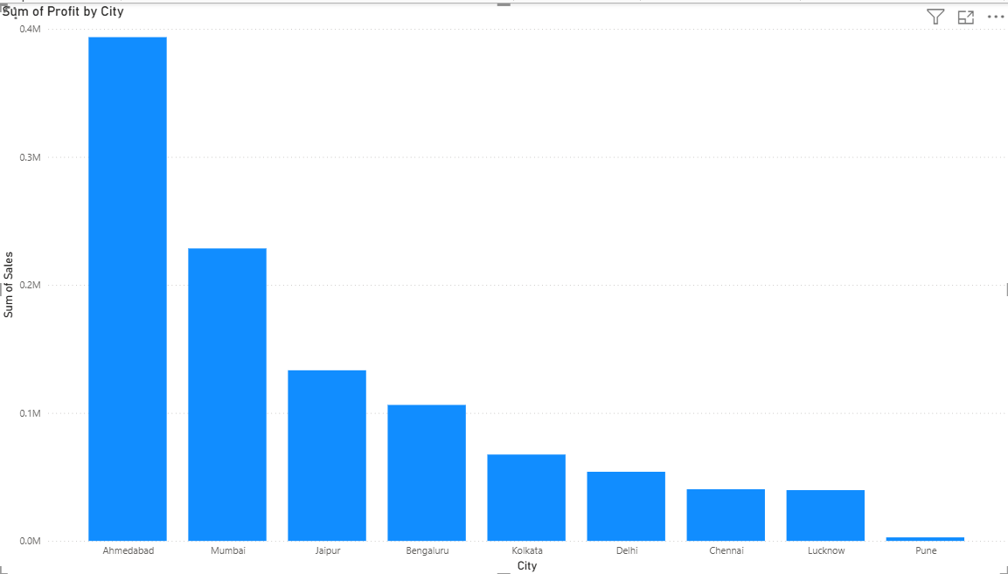

1. **Sales by Month**

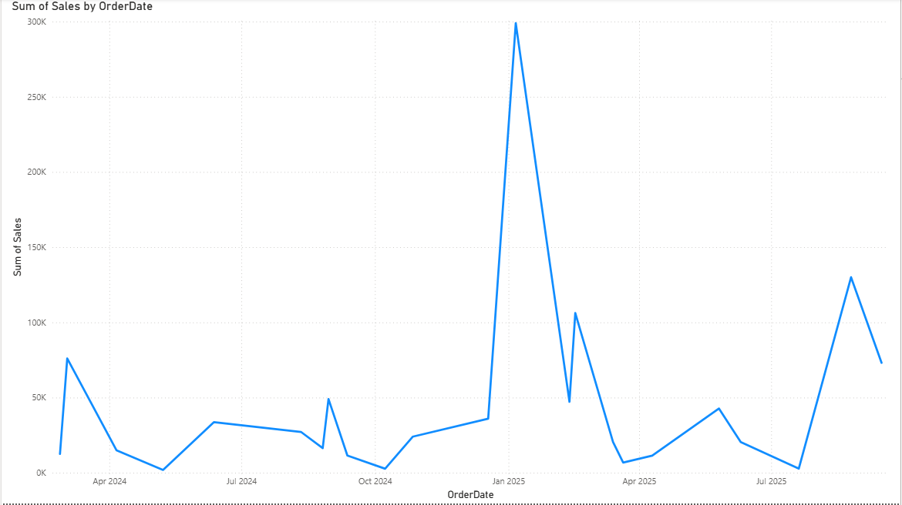

1. **Sales by Category and Sub Category using Drill Though**

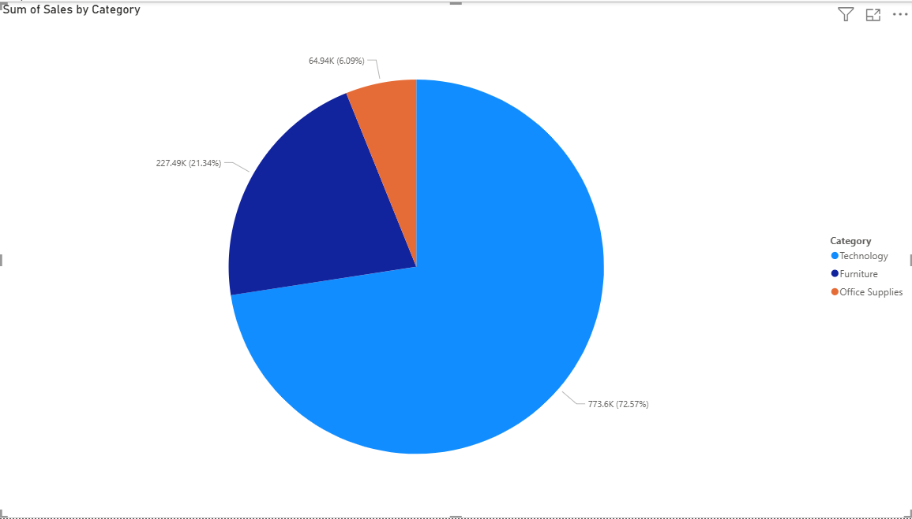

1. **Profit by Category and Sub Category**

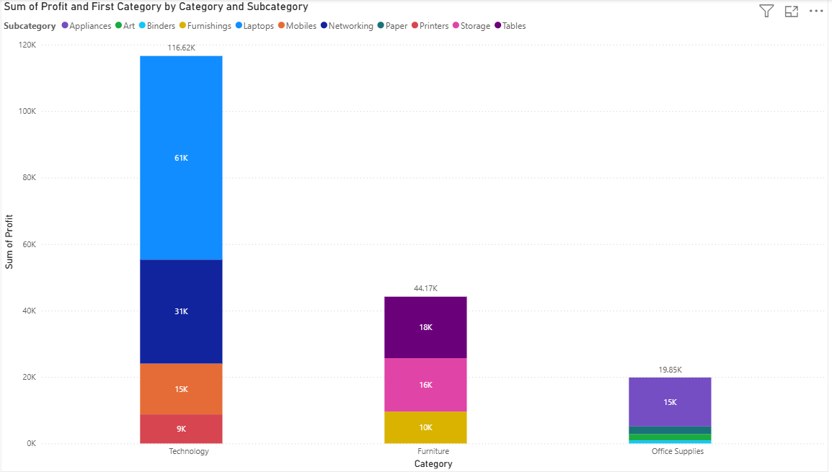

1. **Quantity Sold by Sub-Category**

